Lecture 3.2.1

Graph Coloring
Course outcome to be covered:
CO3: Apply and recognized about the Graph Theory

Topic Objectives

The main objectives of this topic are to
State the definitions of the following terms: Coloring of a simple graph; chromatic number of a graph.
Given a simple graph, find a coloring of the graph using a specified number of colors.
State the Four Color Theorem.
Determine the chromatic number of a graph.
Apply graph coloring to problems in scheduling and other related area.

1. Introduction

In graph Theory, graph coloring is a special case of graph labeling; it is an assignment of labels traditionally called "colors" to elements of a graph subject to certain constraints. In its simplest form, it is a way of coloring the vertices of a graph such that no two adjacent vertices are of the same color; this is called a vertex coloring. Similarly, an edge coloring assigns a color to each edge so that no two adjacent edges are of the same color, and a face coloring of a planar graph assigns a color to each face or region so that no two faces that share a boundary have the same color.

2. Graph Coloring
Graph coloring is the procedure of assignment of colors to each vertex of a graph G such that no adjacent vertices get same color. The objective is to minimize the number of colors while coloring a graph. The smallest number of colors required to color a graph G is called its chromatic number of that graph. Graph coloring problem is a NP Complete problem.

2.1 Method to Color a Graph
The steps required to color a graph G with n number of vertices are as follows −
Step 1 − Arrange the vertices of the graph in some order.
Step 2 − Choose the first vertex and color it with the first color.
Step 3 − Choose the next vertex and color it with the lowest numbered color that has not been colored on any vertices adjacent to it. If all the adjacent vertices are colored with this color, assign a new color to it. Repeat this step until all the vertices are colored.
Example
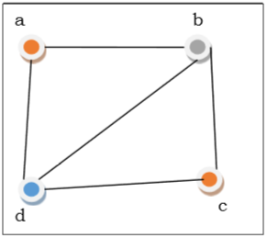
Figure1. Coloring of graph

In the above figure, at first vertex a is colored red. As the adjacent vertices of vertex a are again adjacent, vertex b and vertex d are colored with different color, green and blue respectively. Then vertex c is colored as red as no adjacent vertex of c is colored red. Hence, we could color the graph by 3 colors. Hence, the chromatic number of the graph is 3.

2.2 Applications of Graph Coloring
Some applications of graph coloring include −
- Register Allocation
- Map Coloring
- Bipartite Graph Checking
- Mobile Radio Frequency Assignment
- Making time table, etc.

2.3 Proper Coloring
A coloring is proper if any two adjacent vertices u and v have different colors otherwise it is called improper coloring.
Example2.3.1: Consider the following graph and color C={r, w, b, y}.Color the graph properly using all colors or fewer colors.
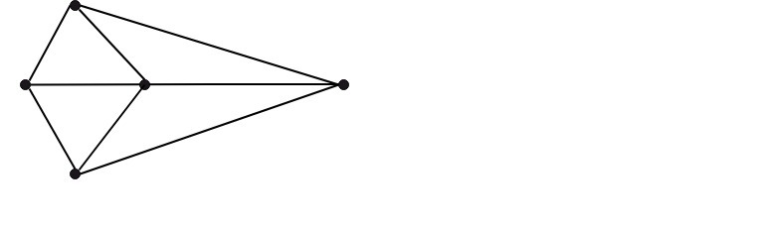
Figure 2(a). Graph for Example 2.3.1
The graph shown in fig is a minimum 3-colorable, hence x(G)=3
Solution: Fig shows the graph properly colored with all the four colors.
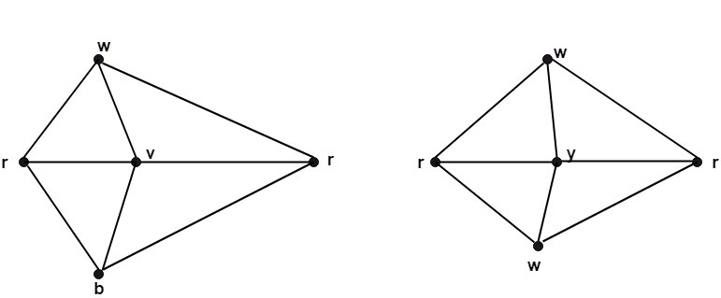
Fig.2(b) shows the graph properly colored with three colors.

2.4 Chromatic number of G
The minimum number of colors needed to produce a proper coloring of a graph G is called the chromatic number of G and is denoted by x(G).
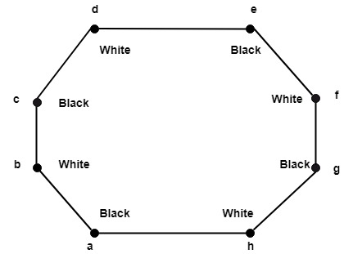
Figure3. Chromatic Number of graph G
Identity 2.4.1 : The chromatic number of K_{n} is n.
Solution: A coloring of K_{n} can be constructed using n colors by assigning different colors to each vertex. No two vertices can be assigned the same colors, since every two vertices of this graph are adjacent. Hence the chromatic number of K_{n}=n.

Example 2.4.2 Find the chromatic number of the graphs below.

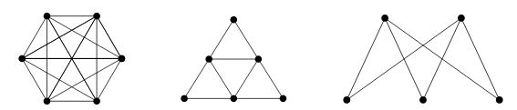

Fig.4(a) Example 2.4.2

The graph on the left is K6. The only way to properly color the graph is to give every vertex a different color (since every vertex is adjacent to every other vertex). Thus the chromatic number is 6.
The middle graph can be properly colored with just 3 colors (Red, Blue, and Green). For example:
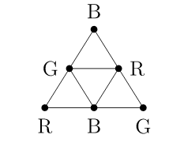
Fig.4(b) Example 2.4.2

There is no way to color it with just two colors, since there are three vertices mutually adjacent (i.e., a triangle). Thus the chromatic number is 3.
The graph on the right is just K2,3.K2,3. As with all bipartite graphs, this graph has chromatic number 2: color the vertices on the top row red and the vertices on the bottom row blue.

Key Observation 2.4.3
The key observation is that while it is true that for any number n,n, there is a graph with chromatic number n, only some graphs arrive as representations of maps. If you convert a map to a graph, the edges between vertices correspond to borders between the countries. So you should be able to connect vertices in such a way where the edges do not cross. In other words, the graphs representing maps are all planar!
So the question is, what is the largest chromatic number of any planar graph? The answer is the best known theorem of graph theory:
It appears that there is no limit to how large chromatic numbers can get. It should not come as a surprise that Kn has chromatic number n. So how could there possibly be an answer to the original map coloring question? If the chromatic number of graph can be arbitrarily large, then it seems like there would be no upper bound to the number of colors needed for any map.

Theorem2.4.4. The Four Color Theorem.

If G is a planar graph, then the chromatic number of G is less than or equal to 4. Thus any map can be properly colored with 4 or fewer colors.

We will not prove this theorem. Really, Even though the theorem is easy to state and understand, the proof is not. In fact, there is currently no “easy” known proof of the theorem. The current best proof still requires powerful computers to check an unavoidable set of 633 reducible configurations. The idea is that every graph must contain one of these reducible configurations (this fact also needs to be checked by a computer) and that reducible configurations can, in fact, be colored in 4 or fewer colors.

2.4.5 Coloring Edges
The chromatic number of a graph tells us about coloring vertices, but we could also ask about coloring edges. Just like with vertex coloring, we might insist that edges that are adjacent must be colored differently. Here, we are thinking of two edges as being adjacent if they are incident to the same vertex. The least number of colors required to properly color the edges of a graph GG is called the chromatic index of G, written χ′(G) .

Example2.4.5.1
Six friends decide to spend the afternoon playing chess. Everyone will play everyone else once. They have plenty of chess sets but nobody wants to play more than one game at a time. Games will last an hour (thanks to their handy chess clocks). How many hours will the tournament last?
Solution
Represent each player with a vertex and put an edge between two players if they will play each other. In this case, we get the graph K6

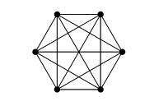
Fig.5 Example 2.4.5.1 for complete graph K₆

We must color the edges; each color represents a different hour. Since different edges incident to the same vertex will be colored differently, no player will be playing two different games (edges) at the same time. Thus we need to know the chromatic index of K6.
Notice that for sure χ′(K6)≥5, since there is a vertex of degree 5. It turns out 5 colors is enough (go find such a coloring). Therefore the friends will play for 5 hours.
Interestingly, if one of the friends in the above example left, the remaining 5 chess-letes would still need 5 hours: the chromatic index of K5K5 is also 5.

In general, what can we say about chromatic index? Certainly χ′(G)≥Δ(G).But how much higher could it be? Only a little higher.

Summary
- Introduction Graph coloring is a special case of graph labeling; it is an assignment of labels traditionally called "colors" to elements of a graph subject to certain constraints.
- Graph coloring is the procedure of assignment of colors to each vertex of a graph G such that no adjacent vertices get same color.
- Proper vertex Coloring A coloring is proper if any two adjacent vertices u and v have different colors otherwise it is called improper coloring.
- Chromatic Number The minimum number of colors needed to produce a proper coloring of a graph G
- Four Coloring Theorem If G is a planar graph, then the chromatic number of G is less than or equal to 4. Thus any map can be properly colored with 4 or fewer colors
- Edge Coloring Just like with vertex coloring, we might insist that edges that are adjacent must be colored differently

Applications of Graph Coloring:
The graph coloring problem has huge number of applications.
1) Making Schedule or Time Table: Suppose we want to make am exam schedule for a university. We have list different subjects and students enrolled in every subject. Many ssubjects would have common students (of same batch, some backlog students, etc). How do we schedule the exam so that no two exams with a common student are scheduled at same time? How many minimum time slots are needed to schedule all exams? This problem can be represented as a graph where every vertex is a subject and an edge between two vertices mean there is a common student. So this is a graph coloring problem where minimum number of time slots is equal to the chromatic number of the graph.
2) Mobile Radio Frequency Assignment: When frequencies are assigned to towers, frequencies assigned to all towers at the same location must be different. How to assign frequencies with this constraint? What is the minimum number of frequencies needed? This problem is also an instance of graph coloring problem where every tower represents a vertex and an edge between two towers represents that they are in range of each other.
3) Sudoku: Sudoku is also a variation of Graph coloring problem where every cell represents a vertex. There is an edge between two vertices if they are in same row or same column or same block.
4) Register Allocation: In compiler optimization, register allocation is the process of assigning a large number of target program variables onto a small number of CPU registers. This problem is also a graph coloring problem.
5) Bipartite Graphs: We can check if a graph is Bipartite or not by coloring the graph using two colors. If a given graph is 2-colorable, then it is Bipartite, otherwise not. See this for more details.
6) Map Coloring: Geographical maps of countries or states where no two adjacent cities cannot be assigned same color. Four colors are sufficient to color any map (See Four Color Theorem)

FAQs
- What is map color problem?
Map coloring is the act of assigning different colors to different features on a map. ... The second is in mathematics, where the problem is to determine the minimum number of colors needed to color a map so that no two adjacent features have the same color.
- Why is four color theorem important?
The Four Color Theorem. ... In mathematics, the Four Color Theorem (or Map Coloring Problem) states that, given any separation of a plane into contiguous regions (producing a figure we will call a map), no more than four colors are required to color the regions of the map so that no two adjacent regions have the same color

References:
Video Links:
- https://www.youtube.com/watch?v=_sdVx_dWnlk
- https://www.youtube.com/watch?v=23lQJjTkx2o
- https://www.youtube.com/watch?v=J7g5HMZgKMU
- https://www.youtube.com/watch?v=4FE79y_JkCE
Website:
- https://www.cs.sfu.ca/~ggbaker/zju/math/colouring.html
- https://mathworld.wolfram.com/VertexColoring.html
- https://www.whitman.edu/mathematics/cgt_online/book/section05.08.html
Courses:
- https://www.coursera.org/specializations/discrete-mathematics
- https://nptel.ac.in/courses/106/106/106106094/
- https://www.udemy.com/course/discrete-math/

